# Michael Steenkamp

# Prof. McHann

5-2 Project One  
September 15st, 2022

# CS 255 Business Requirements Document (From Template)

## System Components and Design

### Purpose

*What is the purpose of this project? Who is the client and what do they want their system to be able to do?*

* The client is Liam, owner of the company DriverPass.
* The purpose of the system is to provide better driver training.
* The system needs to be able to manage online classes and practice tests, as well as road training.

### System Background

*What does DriverPass want the system to do? What is the problem they want to fix? What are the different components needed for this system?*

* The system needs to be available on both computers and phones and it should be able to store data that can be accessed by authorized personal both online and offline. Reports and other data should be downloadable. Different roles should be implemented to allow specifics rights (used for account management). System needs to keep track of any account changes (tracking used for activity report, ex. Who made a reservation). Customers need to be able to make and modify reservations for driving lessons (Customer provides chooses package, pickup location, drop-off location etc.). System needs to keep track of which cars and drivers are available and needs to track which user is matched up with which driver and car, and at what time the lesson will take place. Login credentials is required per user as well as credential modifications/resets. The system needs to provide the user access to online classes and tests as well as information such as lesson start time, score, status etc. Lastly, the system needs to be connected to the DMV so that they can provide updates to policies, rules, and sample questions (user gets notification).
* The different components include data security, user information, online classes and practice tests, road training scheduling/modifying, system data tracking, and DMV communication.
* The problem that DriverPass wants to fix is that the passing rate at the DMV to too low and so they want to provide better training.

### Objectives and Goals

*What should this system be able to do when it is completed? What measurable tasks need to be included in the system design to achieve this?*

* The system will allow the user to perform the following:
  + Access classes
  + Take test
  + Schedule driving lessons
  + Access user information (classes attended, test scores, hours of driving training left, etc.)
* The system will allow authorized user to perform the following:
  + Access system data (printable)
  + Access reports (printable)
  + Manage/Access all accounts (used for login troubleshooting, blocking accounts, etc.)
* The system will collect data from the following:
  + DMV (used for updates on policies, rules, and provides new sample questions)

## Requirements

### Nonfunctional Requirements

*In this section, you will detail the different nonfunctional requirements for the DriverPass system. You will need to think about the different things that the system needs to function properly.*

#### Performance Requirements

*What environments (web-based, application, etc.) does this system need to run in? How fast should the system run? How often should the system be updated?*

* The system needs to be web-based so that the user can access it via an internet browser. The website needs to load in less than 4 seconds with a response time less than 700 milliseconds in all scenarios. The system information such as user accounts and DMV rules and regulations need to be updated every time there is a change made. A system update as a whole should only occur once there is fault with it (changes to the internet browser etc.) or the client requests such an action.

#### Platform Constraints

*What platforms (Windows, Unix, etc.) should the system run on? Does the back end require any tools, such as a database, to support this application?*

* The website should be available on all platforms and should be available through all internet browsers such as chrome, safari, opera GX, etc. The website will need a designated server to host it as well as store relative data such as user accounts and DMV information. The system also needs to be connected to the local DMV so that they can send related updates to not only the website but also individual users such as the owner.

#### Accuracy and Precision

*How will you distinguish between different users?* *Is the input case-sensitive? When should the system inform the admin of a problem?*

* Each user will have a different role assigned to them, depending on the role that they have assigned towards them will determine their authority within the system. For example, the owner of DriverPass will have the role ‘Owner’ which allows full administrative access to the system so that changes can be made. User login information is case sensitive as well as any other security access information. The system should do a self-diagnosis every day one minute past midnight (local time of server) to determine if any problems a have occurred internally, it should immediately inform the admin. Other problems should be reported by users and employees through the website to the admin. If an input is invalid such as login information, then an error popup should appear within half a second.

#### Adaptability

*Can you make changes to the user (add/remove/modify) without changing code? How will the system adapt to platform updates? What type of access does the IT admin need?*

* The system will be able to make changes to the user without changing code by using standard object-oriented programming concepts such as encapsulation, polymorphism, abstraction, and inheritance. The system will adapt to platform changes by informing the admin of any browser changes that might interfere with the systems infrastructure. The system will need maintenance and updates according to these platform changes. The IT admin will need access to the source code so that they can make changes to the system, if need be, they will also need access to the documentation that was used to construct the system (diagrams, design documents etc.). The system will need to adapt to every platform that it is accessible by in order to function properly, to do so the IT admin will have to monitor any changes from the platforms and act accordingly.

#### Security

*What is required for the user to log in? How can you secure the connection or the data exchange between the client and the server? What should happen to the account if there is a “brute force” hacking attempt? What happens if the user forgets their password?*

* In order for the user to log in they will have to provide a username or email address as well as a password; these will be created when the user creates an account. In order to secure the data exchange between the client and the server we will be using encryption to encrypt the data, using a private and public key this data will then be decrypted by the receiver. In order to prevent a “brute force” hacking attempt we will not allow more than three failed login attempts at one time on the same account. If the user forgets their password, then they can use one of two on-screen links to either contact customer support or to reset their password via email.

### Functional Requirements

*Using the information from the scenario, think about the different functions the system needs to provide. Each of your bullets should start with “The system shall . . .” For example, one functional requirement might be, “The system shall validate user credentials when logging in.”*

* The system shall allow data to be downloaded for offline access
* The system shall provide different roles that can be assigned to the appropriate users
* The system shall allow the owner to reset all account passwords individually
* The system shall track who made a reservation
* The system shall track who canceled a reservation
* The system shall track who modified a reservation
* The system shall store an activity report
* The system shall allow authorized users to access and print the activity report
* The system shall allow authorized users to cancel, modify, and make driving appointments
* The system shall allow users who have reservations to choose a data and time for the lesson
* The system shall allow users who have reservations to choose a pickup and drop-off location
* The system shall allow customers to contact support
* The system shall track which user is scheduled with which driver
* The system shall track which user is scheduled with which car
* The system shall track which user is scheduled for what time (for a driving lesson)
* The system shall provide three different driving packages to choose from
* The system shall allow new users to create an account
* The system shall allow existing users to login to an account
* The system shall verify login credentials
* The system shall provide a ‘reset password’ link
* The system shall store and modify user data onto the server
* The system shall access user data from the server
* The system shall send a verification email to each new customer upon creation of their account
* The system shall send confirmation email to the owner
* The system shall receive any updates from the local DMV
* The system shall notify the owner when there are any updates from the local DMV
* The system shall allow users access to tests
* The system shall do self-diagnostics
* The system shall notify the owner if any system errors occur

### User Interface

*What are the needs of the interface? Who are the different users for this interface? What will each user need to be able to do through the interface? How will the user interact with the interface (mobile, browser, etc.)?*

* The user interface will have to include the following:
  + The DriverPass Logo
  + Driver notes section
  + Online test progress section
  + User information section
  + Special needs section
  + Driver photo
  + Student photo
* The ‘test progress’ section will show which of the test the customer has already taken, is taking, and still needs to take. The layout will be name, time taken, score, and status; with the status section provides the status of each test as well as a grade (passing or failing)
* The ‘driver notes’ section will be in the format of a table with the columns representing lesson time, start hour, end hour, and driver comments.
* This page will be the main page for the customers, thus there will many other pages such as one dedicated to the secretaries where they can fill in user information, a page where the company contact information is as well as direct contact with each other through the website.
* Each of the users of the site will need to interact with the user interface whether they are the owner, admin, secretary, or customer. Each of these users will have different needs from the interface, for example the owner might not need access to the different lesson because they will not be partaking in one. Since the system based online with the use of a website, generally the user interface will be interacted with via an internet browser from a computer, so it needs to be compatible with a mouse and keyboard. Touch based devices such as smart phones are also able to access the website via an internet browser so, the website and its user interface should also be interactable with a touch-based device.

### Assumptions

*What things were not specifically addressed in your design above? What assumptions are you making in your design about the users or the technology they have?*

* Assumptions about the system include:
  + The DMV allows for external sources (the system) to communicate with them
  + The DriverPass company has lessons and tests set up to implement
  + DriverPass has a banking account used for payment through the website
  + The colour scheme/theme of the website was not discussed
  + The company has a domain name for the website
  + The system will be hosted from a server located at the DriverPass company
  + The system is made from scratch and not through a third party
* Assumptions about the user include:
  + The user understands how to use the website
  + The user has an internet connection
  + The user is not blind
  + The user does not have a license
  + The user has access to a device that can access the system
  + The user can read English

### Limitations

*Any system you build will naturally have limitations. What limitations do you see in your system design? What limitations do you have as far as resources, time, budget, or technology?*

* Some limitations for this system would include storage space, platform, accessibility, budget, features. Firstly, since the system is web-based there would need to be a designated server running and soring all the data, this will take a lot of storage space which may be a limitation down the road as more customers use the system. Another limitation is platform; as for now the system will only be accessible through the internet via an internet browser, this can result in many limitations such as network connections, availability, access to appropriate devices, etc. Not all potential customers will have access to the internet or devices capable of using internet browsers which will limit the number of customers that DriverPass will receive. Finally, the budget will be another limitation because as the project increases in size with new features and dependencies the budget will also increase which will result in one of two scenarios, Driverpass is willing to increase the budget thus more features can be added or the scope of the project will have to be reevaluated.

### Gantt Chart

*Please include a screenshot of the GANTT chart that you created with Lucidchart. Be sure to check that it meets the plan described by the characters in the interview.*

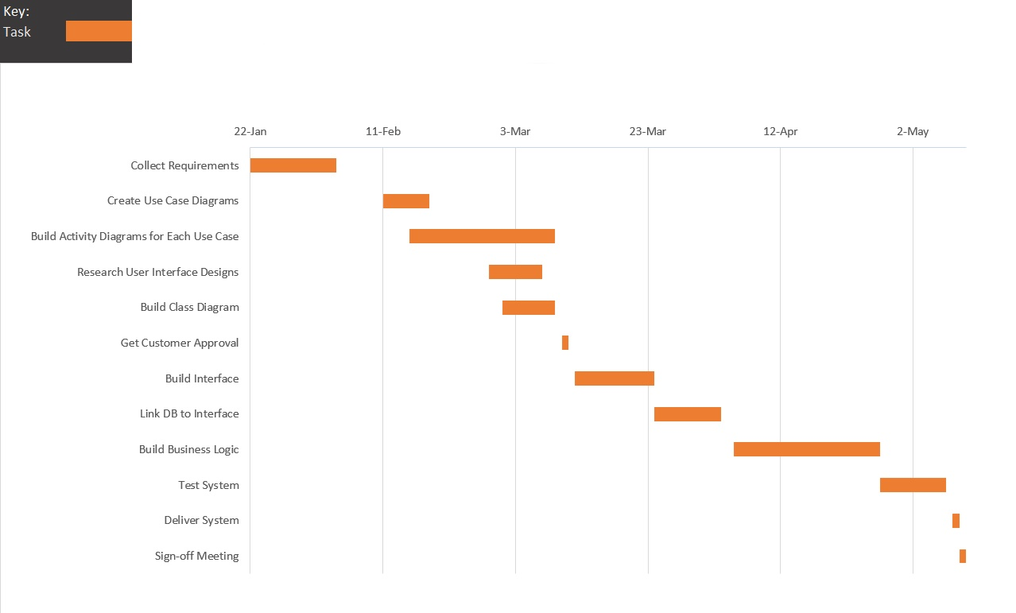

Work Cited:

Online PM Courses - Mike Clayton. (2019, February 27). Project Management in under 5: What is a gantt chart? YouTube. Retrieved October 1, 2022, from <https://www.youtube.com/watch?v=fB0wsdmV3Sw>

Almond Careers - Project Management Training with Work Experience. (2019, March 21). How to gather functional &amp; non-functional requirement. YouTube. Retrieved October 1, 2022, from <https://www.youtube.com/watch?v=v1-b2hspIb4>

Mors Professional Gaming Workshop. Constraints, Limitations, and Assumptions. (n.d.). Retrieved October 1, 2022, from <http://www.opanalytics.ca/MORS/cla.html>

Southern New Hampshire University. (n.d.). CS 255 DriverPass Interview Transcript.

Functional vs non-functional requirements - understand the difference. ReQtest. (2020, July 28). Retrieved October 1, 2022, from <https://reqtest.com/requirements-blog/functional-vs-non-functional-requirements/>

Stroud, J. D. L. (2018, December 17). Business Requirements Document: A high-level review. iSixSigma. Retrieved October 1, 2022, from <https://www.isixsigma.com/implementation/project-selection-tracking/business-requirements-document-high-level-review/>